**PHASE-1 PROJECT**

**LOGIN PAGE**

**FRAME 1**

<html>

<head>

<style>

p{

color:black;

font-family:arial;

font-size:19px;

}

input[type=button] {

background-color: ff499e;

border: none;

color: white;

padding: 8px 16px;

}

form{

min-height: 100vh;

display: flex;

align-items: center;

}

</style>

</head>

<body bgcolor="#ffdc5e">

<form>

<table border=0 align="center">

<tr><td>

<h1> LOGIN PAGE</h1>

</td></tr>

<tr><td>

<p>Username</p></td></tr>

<tr><td>

<input type="text" name="user" />

</td></tr>

<tr><td>

<p>Password:</p></td></tr>

<tr><td>

<input type="password" name="pass" />

</td></tr>

<center>

<tr><td>

<input type="button" value="LOGIN">

</td></tr></center

</table>

</form>

</body>

</html>

**FRAME 2**

<html>

<body>

<img src="b.jpg" height=800 width=800>

</body>

</html>

**LOGIN PAGE**

<html>

<head>

<frameset cols=50%,50% border=0>

<frame name="top" src="frame1.html" scrolling="no">

<frame name="mid1" src="frame2.html" scrolling="no">

</frameset>

</head>

</html>

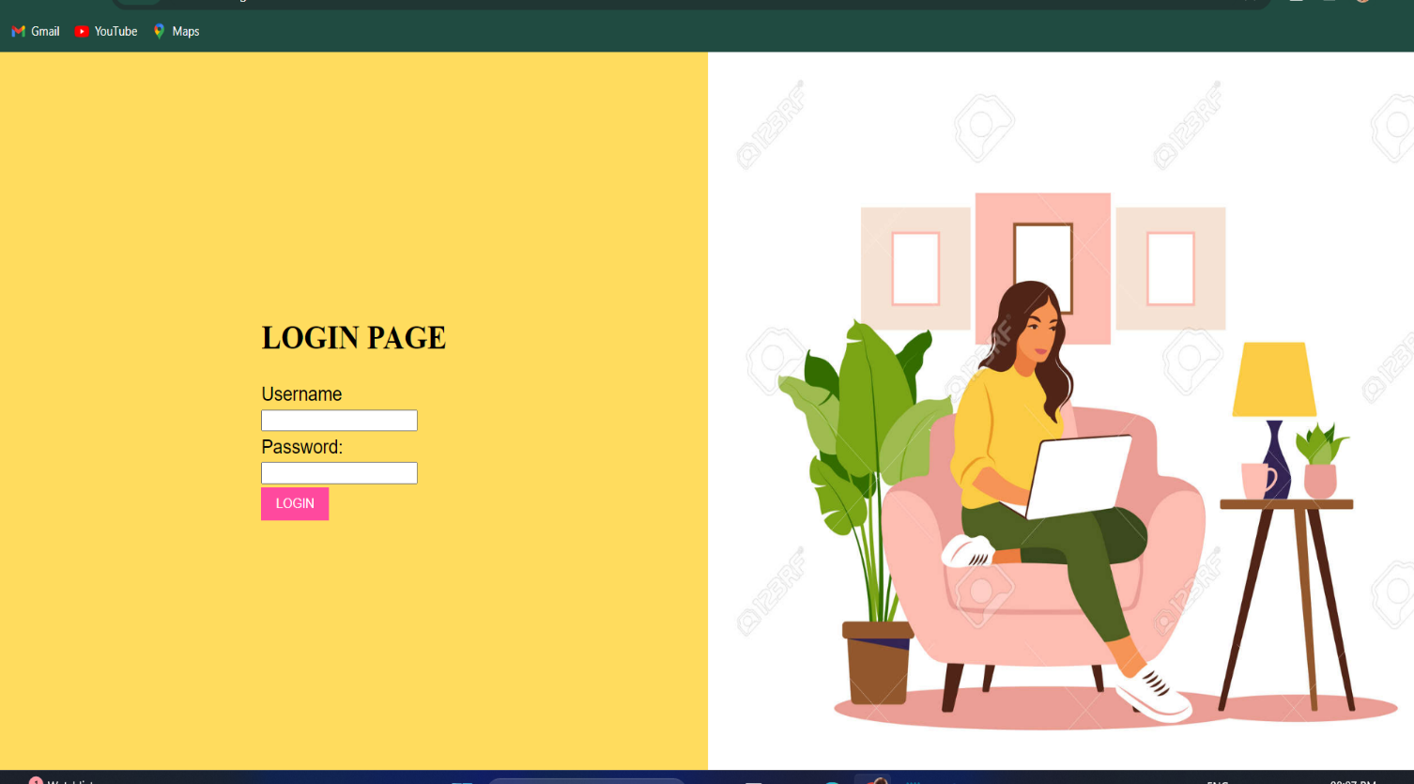**OUTPUT**

**SIGN-UP PAGE**

**FRAME 1**

<html>

<head>

<style>

p{

color:black;

font-family:arial;

font-size:19px;

}

input[type=button] {

background-color: ff499e;

border: none;

color: white;

padding: 8px 16px;

}

form{

min-height: 100vh;

display: flex;

align-items: center;

}

</style>

</head>

<body bgcolor="#ffdc5e">

<form>

<table border=0 align="center">

<tr>

<td>

<h4 align="center">sign up to create an account</h4>

</td></tr>

<tr><td>

<h1> SIGN UP</h1></td></tr>

<tr><td>

<p>E-Mail</p></td></tr>

<tr><td>

<input type="text" name="mail" />

</td></tr>

<tr><td>

<p>Password</p></td></tr>

<tr><td>

<input type="password" name="pass" />

</td></tr>

<tr><td>

<p>Confirm Password</p></td></tr>

<tr><td>

<input type="password" name="pass" />

</td></tr>

<center>

<tr><td>

<input type="button" value="LOGIN">

</td></tr></center

</table>

</form>

</body>

</html>

**FRAME 2**

<html>

<body>

<img src="b.jpg" height=800 width=800>

</body>

</html>

**SIGN-UP PAGE**

<html>

<head>

<frameset cols=50%,50% border=0>

<frame name="top" src="frame1.html" scrolling="no">

<frame name="mid1" src="frame2.html" scrolling="no">

</frameset>

</head>

</html>

**OUTPUT**

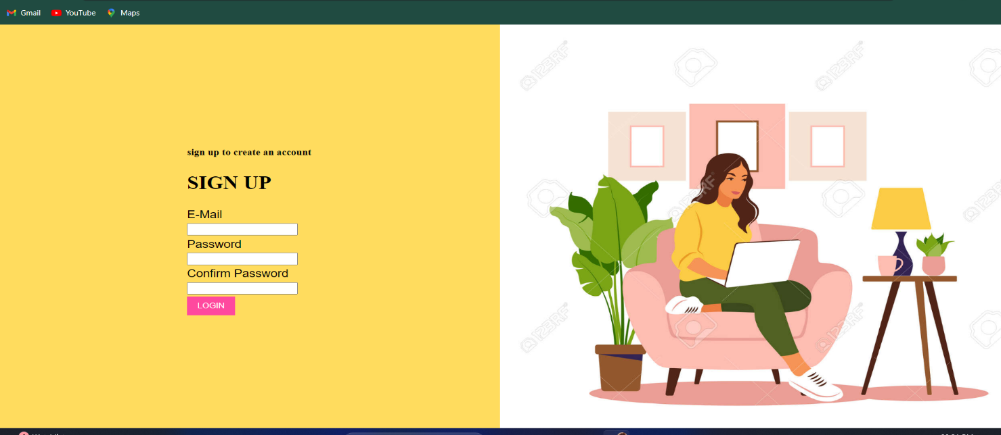

**SIGN-UP PAGE FOR RESTAURANT**

**SIGN UP PAGE**

<html>

<head>

<style>

input[type=button] {

background-color:black;

border: none;

color: white;

padding: 8px 16px;

}

form{

min-height: 40vh;

display: flex;

align-items: center;

}

</style>

</head>

<body bgcolor="#ddb892">

<img src ="lo.png" height=70 width=70 align="left">

<table border=0 align="center" >

<tr>

<td><b>What We Offer</b>

&nbsp;&nbsp;&nbsp;&nbsp;&nbsp;&nbsp;

<b>Login</b>

&nbsp;&nbsp;&nbsp;&nbsp;&nbsp;&nbsp;

<input type="button" value="Sign up">

</td></tr>

</table>

<hr>

<br>

<br>

<img src="f3.png" height=600 width=600 align="right">

<p style="text-align:center; color:#582f0e; font-size:50px;">

<b>Craving For Food?</b></p>

<form>

<table border=0 align="center">

<tr><td>

<h1> SIGN UP</h1></td></tr>

<tr><td>

<p>E-Mail</p></td></tr>

<tr><td>

<input type="text" name="mail" />

</td></tr>

<tr><td>

<p>Password</p></td></tr>

<tr><td>

<input type="password" name="pass" />

</td></tr>

<tr><td>

<p>Confirm Password</p></td></tr>

<tr><td>

<input type="password" name="pass" />

</td></tr>

<center>

<tr><td>

<input type="button" value="SIGN UP">

</td></tr></center

</table>

</form>

</body>

</html>

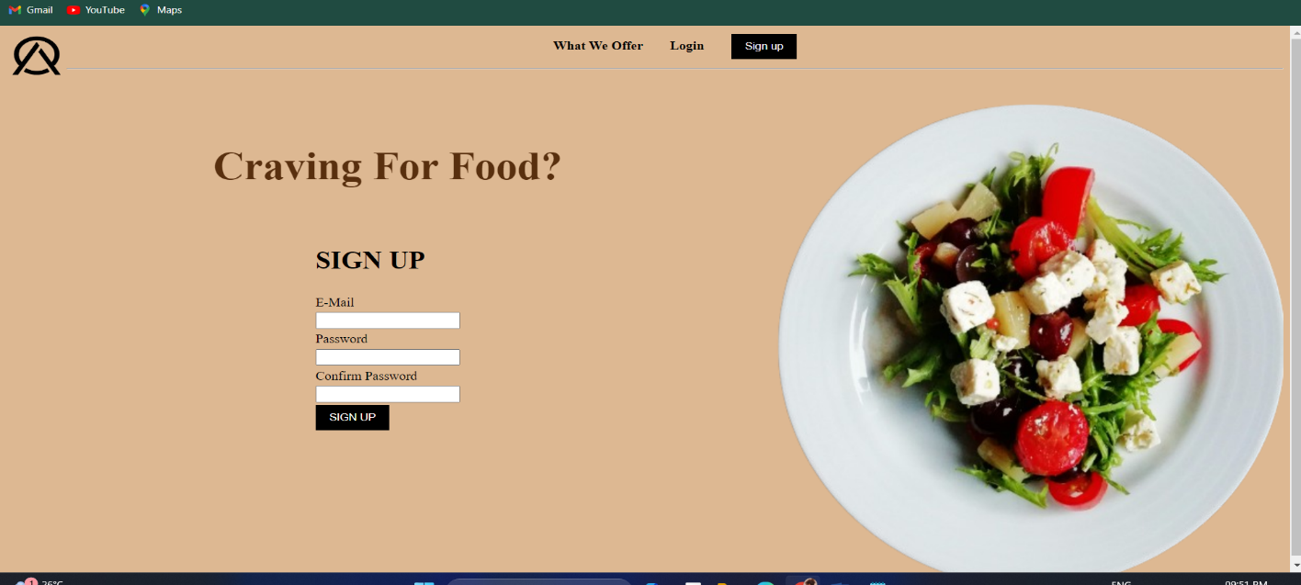**OUTPUT**

**LOGIN PAGE**

<html>

<head>

<style>

input[type=button] {

background-color:#7f4f24;

border: none;

color: white;

padding: 8px 16px;

}

form{

min-height: 40vh;

display: flex;

align-items: center;

}

</style>

</head>

<body bgcolor="#ddb892">

<img src ="lo.png" height=70 width=70 align="left">

<table border=0 align="center" >

<tr>

<td><b>What We Offer</b>

&nbsp;&nbsp;&nbsp;&nbsp;&nbsp;&nbsp;

<input type="button" value="Log In">

&nbsp;&nbsp;&nbsp;&nbsp;&nbsp;&nbsp;

<b>Sign Up</b>

</td></tr>

</table>

<hr>

<br>

<br>

<img src="f1.png" height=600 width=600 align="right">

<p style="text-align:center; color:#582f0e; font-size:50px;">

<b>Craving For Food?</b></p>

<form>

<table border=0 align="center">

<tr><td>

<h1> LOGIN PAGE</h1>

</td></tr>

<tr><td>

<p>Username</p></td></tr>

<tr><td>

<input type="text" name="user" />

</td></tr>

<tr><td>

<p>Password:</p></td></tr>

<tr><td>

<input type="password" name="pass" />

</td></tr>

<center>

<tr><td>

<input type="button" value="LOGIN">

</td></tr></center

</table>

</form>

</body>

</html>

**OUTPUT**

